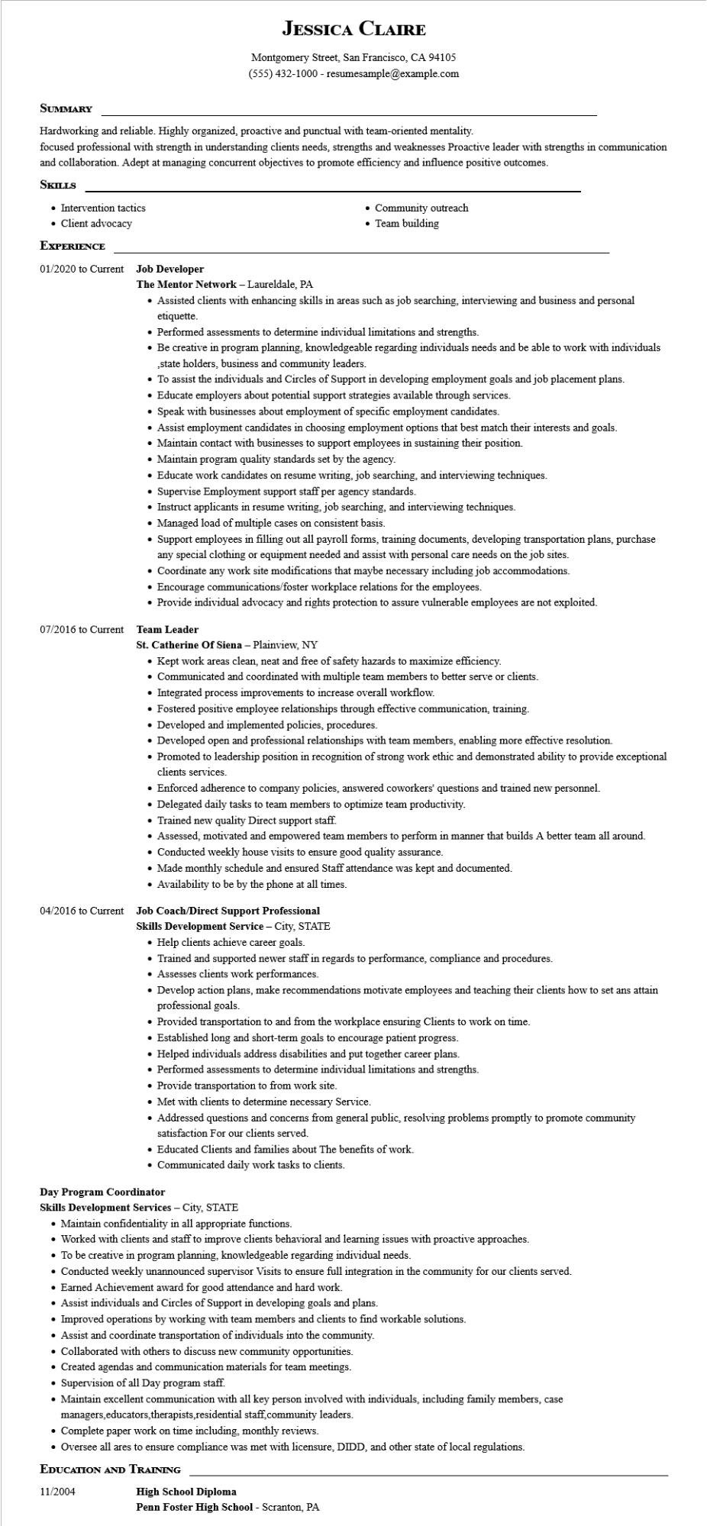
JESSICA CLAIRE
Montgomery Street, San Francisco, CA 94105
(555) 432-1000 - resumesample@example.com
SUMMARY
Hardworking and reliable. Highly organized, proactive and punctual with team-oriented mentality.
focused professional with strength in understanding clients needs, strengths and weaknesses Proactive leader with strengths in communication and collaboration. Adept at managing concurrent objectives to promote efficiency and influence positive outcomes.
SKILLS
• Intervention tactics.
• Client advocacy
• Community outreach • Team building
EXPERIENCE
01/2020 to Current Job Developer
The Mentor Network - Laureldale, PA
• Assisted clients with enhancing skills in areas such as job searching, interviewing and business and personal etiquette.
• Performed assessments to determine individual limitations and strengths.
• Be creative in program planning, knowledgeable regarding individuals needs and be able to work with individuals ,state holders, business and community leaders.
• To assist the individuals and Circles of Support in developing employment goals and job placement plans.
• Educate employers about potential support strategies available through services.
Speak with businesses about employment of specific employment candidates.
• Assist employment candidates in choosing employment options that best match their interests and goals.
• Maintain contact with businesses to support employees in sustaining their position.
• Maintain program quality standards set by the agency.
• Educate work candidates on resume writing, job searching, and interviewing techniques.
• Supervise Employment support staff per agency standards.
• Instruct applicants in resume writing, job searching, and interviewing techniques.
• Managed load of multiple cases on consistent basis.
• Support employees in filling out all payroll forms, training documents, developing transportation plans, purchase
any special clothing or equipment needed and assist with personal care needs on the job sites.
• Coordinate any work site modifications that maybe necessary including job accommodations.
• Encourage communications/foster workplace relations for the employees.
• Provide individual advocacy and rights protection to assure vulnerable employees are not exploited.
07/2016 to Current
Team Leader
St. Catherine Of Siena - Plainview, NY
• Kept work areas clean, neat and free of safety hazards to maximize efficiency.
• Communicated and coordinated with multiple team members to better serve or clients.
• Integrated process improvements to increase overall workflow.
• Fostered positive employee relationships through effective communication, training.
• Developed and implemented policies, procedures.
• Developed open and professional relationships with team members, enabling more effective resolution.
• Promoted to leadership position in recognition of strong work ethic and demonstrated ability to provide exceptional clients services.
• Enforced adherence to company policies, answered coworkers' questions and trained new personnel.
• Delegated daily tasks to team members to optimize team productivity.
• Trained new quality Direct support staff.
• Assessed, motivated and empowered team members to perform in manner that builds A better team all around.
• Conducted weekly house visits to ensure good quality assurance.
• Made monthly schedule and ensured Staff attendance was kept and documented.
• Availability to be by the phone at all times.
04/2016 to Current Job Coach/Direct Support Professional
Skills Development Service - City, STATE
• Help clients achieve career goals.
• Trained and supported newer staff in regards to performance, compliance and procedures.
• Assesses clients work performances.
• Develop action plans, make recommendations motivate employees and teaching their clients how to set ans attain professional goals.
• Provided transportation to and from the workplace ensuring Clients to work on time.
• Established long and short-term goals to encourage patient progress.
• Helped individuals address disabilities and put together career plans.
• Performed assessments to determine individual limitations and strengths.
• Provide transportation to from work site.
• Met with clients to determine necessary Service.
• Addressed questions and concerns from general public, resolving problems promptly to promote community satisfaction For our clients served.
• Educated Clients and families about The benefits of work.
• Communicated daily work tasks to clients.
Day Program Coordinator
Skills Development Services - City, STATE
• Maintain confidentiality in all appropriate functions.
• Worked with clients and staff to improve clients behavioral and learning issues with proactive approaches.
• To be creative in program planning, knowledgeable regarding individual needs.
• Conducted weekly unannounced supervisor Visits to ensure full integration in the community for our clients served.
• Earned Achievement award for good attendance and hard work.
• Assist individuals and Circles of Support in developing goals and plans.
• Improved operations by working with team members and clients to find workable solutions.
• Assist and coordinate transportation of individuals into the community.
• Collaborated with others to discuss new community opportunities.
• Created agendas and communication materials for team meetings.
• Supervision of all Day program staff.
• Maintain excellent communication with all key person involved with individuals, including family members, case managers, educators, therapists,residential staff, community leaders.
• Complete paper work on time including, monthly reviews.
• Oversee all ares to ensure compliance was met with licensure, DIDD, and other state of local regulations.
EDUCATION AND TRAINING
11/2004
High School Diploma
Penn Foster High School - Scranton, PA

